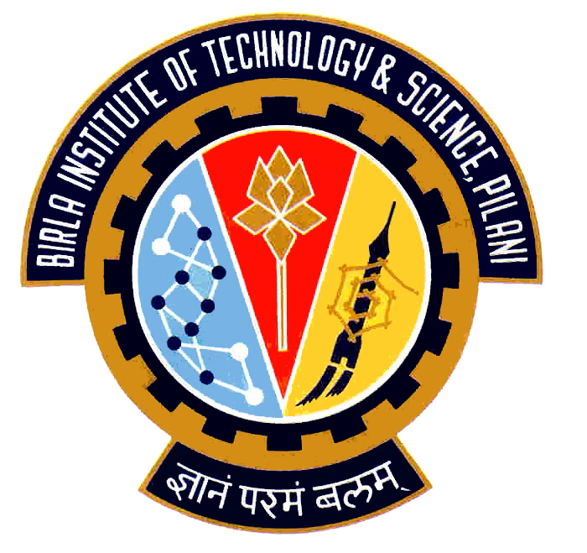

Election Commission

Birla Institute of Technology & Science – Pilani, Goa Campus, Zuarinagar, Goa-403726, INDIA
Tel: (0)98233 6368 Fax:0832-2557033

Final List of Candidates for Hostel Representatives:

CH 2

CULTURAL
VAIBHAV KUMAR SHARMA | 2007T6PS576
HOSTEL AND CAMPUS MANAGEMENT
MANISH RANJAN | 2007P3PS129
S. GANESH | 2007P3PS139
MESS
EKANSH SAXENA | 2007P4PS320
T. PAUL DHINAKAR | 2007P3PS187
SPORTS
ARBAB KAUSAR | 2007P4PS329
RAVIKIRAN K. N. | 2007S1P7610

Chief Warden CEC

